For the first pass at my project I created an
Account entity,
an AccountController.java,
an AccountService.java,
an AccountRepository.java,
an account.js,
an account.jsp view
User.java,
UserRepository.java,
RegistrationService.java,
Registration.jsp
An ajax method is used in account.js to post the form contents to /user/registration. Which the uses the RegistrationService method createNewUser to save a new User and Account in the database. The repository classes use the @Repository annotation which is used to indicate that the class provides the mechanism for storage, retrieval, search, update, and delete operation on objects.
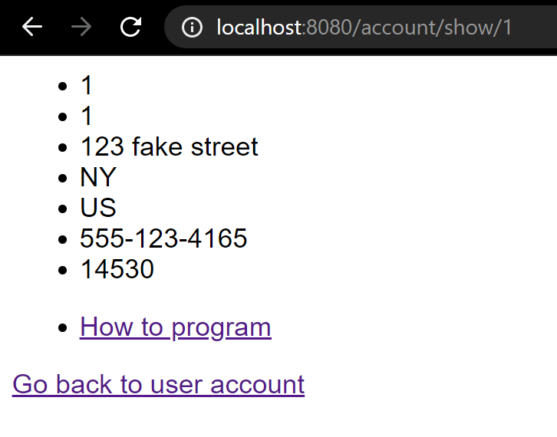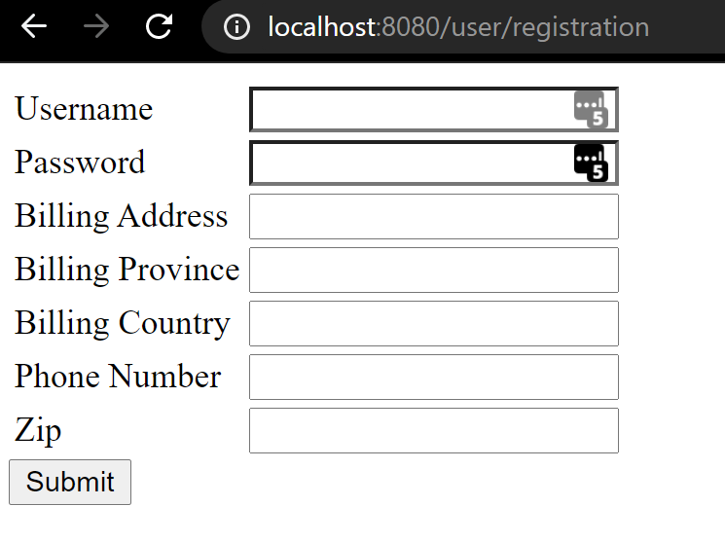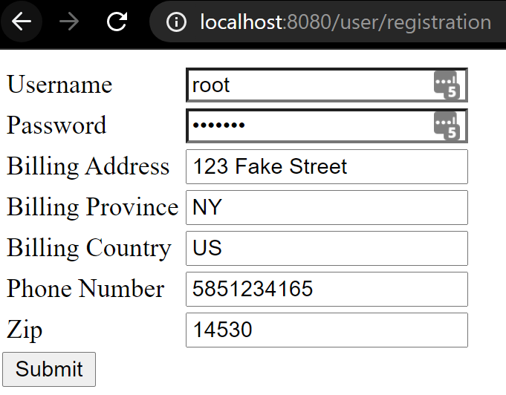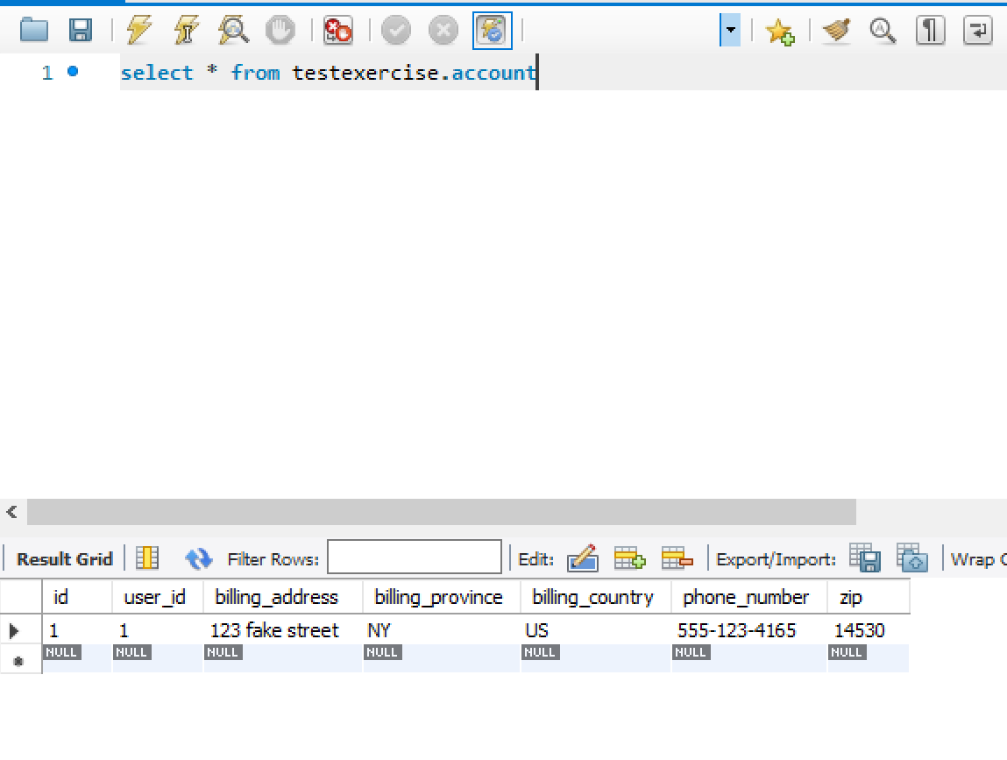

account.jsp
<%@ page contentType="text/html;charset=UTF-8" language="java" %>
<html>
<head>
<title>Account</title>
<link rel="stylesheet"
href="//cdnjs.cloudflare.com/ajax/libs/highlight.js/10.7.1/styles/default.min.css">
<link rel="stylesheet" href="${pageContext.request.contextPath}/static/css/style.css">
</head>
<body>
<div>
<ul>
<li>${account.id}</li>
<li>${account.getUserId()}</li>
<li>${account.getBillingAddress()}</li>
<li>${account.getBillingProvince()}</li>
<li>${account.getBillingCountry()}</li>
<li>${account.getPhoneNumber()}</li>
<li>${account.getZip()}</li>
</ul>
<ul id="books" account-id="${account.getId()}"></ul>
<a href="/user/show/${account.getUserId()}">Go back to user account</a>
</div>
</body>
</html>
<script src="${pageContext.request.contextPath}/static/js/account.js"></script>

registration.jsp
<%@ page contentType="text/html;charset=UTF-8"%>
<html>
<head>
<title>Registration</title>
</head>
<body>
<div>
<table style="with: 50%">
<tr>
<td>Username</td>
<td><input id="username" type="text" name="username" /></td>
</tr>
<tr>
<td>Password</td>
<td><input id="password" type="password" name="password" /></td>
</tr>
<tr>
<td>Billing Address</td>
<td><input id="billing_address" type="text" name="billing_address" /></td>
</tr>
<tr>
<td>Billing Province</td>
<td><input id="billing_province" type="text" name="billing_province" /></td>
</tr>
<tr>
<td>Billing Country</td>
<td><input id="billing_country" type="text" name="billing_country" /></td>
</tr>
<tr>
<td>Phone Number</td>
<td><input id="phone_number" type="text" name="phone_number" /></td>
</tr>
<tr>
<td>Zip</td>
<td><input id="zip" type="text" name="zip" /></td>
</tr>
</table>
<input id="submit" type="submit" value="Submit" />
</div>
</body>
</html>
<script src="${pageContext.request.contextPath}/static/js/registration.js"></script>

Account.java
package com.company.app.model;

import javax.persistence.Entity;
import javax.persistence.GeneratedValue;
import javax.persistence.GenerationType;
import javax.persistence.Id;

@Entity
public class Account {

@Id
@GeneratedValue(strategy = GenerationType.IDENTITY)
private int id;

private int userId;

private String billingAddress;

private String billingProvince;

private String billingCountry;

private String phoneNumber;

private String zip;

public Account() {}

public Account(int userId,
String billingAddress,
String billingProvince,
String billingCountry,
String phoneNumber,
String zip) {
this.userId = userId;
this.billingAddress = billingAddress;
this.billingProvince = billingProvince;
this.billingCountry = billingCountry;
this.phoneNumber = phoneNumber;
this.zip = zip;
}

public int getId() {
return this.id;
}

public void setUserId(int userId) {
this.userId = userId;
}

public int getUserId() {
return userId;
}

public String getBillingAddress() {
return billingAddress;
}

public void setBillingAddress(String billingAddress) {
this.billingAddress = billingAddress;
}

public String getBillingProvince() {
return billingProvince;
}

public void setBillingProvince(String billingProvince) {
this.billingProvince = billingProvince;
}

public String getBillingCountry() {
return billingCountry;
}

public void setBillingCountry(String billingCountry) {
this.billingCountry = billingCountry;
}

public String getPhoneNumber() {
return phoneNumber;
}

public void setPhoneNumber(String phoneNumber) {
this.phoneNumber = phoneNumber;
}

public String getZip() {
return zip;
}

public void setZip(String zip) {
this.zip = zip;
}
}

AccountController.java
@Controller
public class AccountController {
private static final Logger logger = LogManager.getLogger(AccountController.class);
private final AccountService accountService;

@Autowired
public AccountController(AccountService accountService) {
this.accountService = accountService;
}

@PostMapping("/account")
public ResponseEntity<Account> createAccount(@RequestBody Account account) {
account = accountService.save(account);
return new ResponseEntity<Account>(account, HttpStatus.CREATED);
}

@RequestMapping("/account/show/{id}")
public String getAccountViewById(Model model, @PathVariable int id, HttpSession session) {
logger.info("Request to /account/{}",id);
Account account = accountService.findById(id);
logger.info("checking if {} == {}",session.getAttribute("userId"),account.getUserId());
if(!session.getAttribute("userId").equals((Integer)account.getUserId())) {
return "error";
}
model.addAttribute("account", account);
logger.info("Response {}",account);
return "account";
}
}

AccountService.java
@Service
public class AccountService {

private AccountRepository accountRepository;

@Autowired
AccountService(AccountRepository accountRepository){
this.accountRepository = accountRepository;
}

public Account save(Account account) {
return accountRepository.save(account);
}

public void deleteById(int id) {
accountRepository.deleteById(id);
}

public Account updateAccount(Account account, int id) {
Account accountToUpdate = accountRepository.findById(id);
accountToUpdate.setBillingAddress(account.getBillingAddress());
accountToUpdate.setBillingCountry(account.getBillingCountry());
accountToUpdate.setBillingProvince(account.getBillingProvince());
accountToUpdate.setPhoneNumber(account.getPhoneNumber());
accountToUpdate.setZip(account.getZip());
accountToUpdate = accountRepository.save(account);
return accountToUpdate;
}

public Account findById(int id) {
return accountRepository.findById(id);
}

public Account findByUserId(int id) {
return accountRepository.findByUserId(id);
}

}

AccountRepository.java
@Repository
public interface AccountRepository extends CrudRepository<Account, Integer> {

Account findById(int id);
Account findByUserId(int id);
}

User.java
@Entity
@Table(name="user")
public class User {

@Id
@GeneratedValue(strategy = GenerationType.IDENTITY)
private int id;

public User() {}

public User(String userName, String password) {
this.userName = userName;
this.password = password;
}

public User(int id, String userName, String password) {
this.id = id;
this.userName = userName;
this.password = password;
}

private String userName;

private String password;

public int getId() {
return this.id;
}

public void setUserName(String userName) {
this.userName = userName;
}

public String getUserName() {
return this.userName;
}

public void setPassword(String password) {
this.password = password;
}

public String getPassword() {
return this.password;
}
}

UserController.java
@Controller
public class UserController {
private static final Logger logger = LogManager.getLogger(UserController.class);
private final RegistrationService registrationService;

@Autowired
public UserController(RegistrationService registrationService) {
this.registrationService = registrationService;
}

@RequestMapping("/user/registration")
public String showRegistration() {
return "registration";
}

@PostMapping("/user/registration")
public ResponseEntity<HttpStatus> createUser(@RequestBody Registration registration) {
logger.info("/user/registration {}",registration);
if(userService.findByUserName(registration.getUserName()) != null) {
return new ResponseEntity<HttpStatus>(HttpStatus.NOT_ACCEPTABLE);
}
try {
registrationService.createNewUser(registration);
}
catch(Exception e) {
logger.error("/user/registration {}",e.getMessage());
return new ResponseEntity<HttpStatus>(HttpStatus.NOT_ACCEPTABLE);
}
return new ResponseEntity<HttpStatus>(HttpStatus.CREATED);
}
}
UserService.java
Service
public class UserService {

private UserRepository userRepository;

@Autowired
UserService(UserRepository userRepository){
this.userRepository = userRepository;
}

public User findByUserName(String userName) {
return userRepository.findByUserName(userName);
}

public User findById(int id) {
return userRepository.findById(id);
}

public User save(User user) {
return userRepository.save(user);
}

public void deleteById(int id) {
userRepository.deleteById(id);
}

public User updateUserById(User user, int id) {
User userToUpdate = userRepository.findById(id);
userToUpdate.setPassword(user.getPassword());
userToUpdate.setUserName(user.getUserName());
userRepository.save(user);
return userToUpdate;
}
}

UserRepository.java
@Repository
public interface UserRepository extends CrudRepository<User, Integer> {
User findById(int id);
User findByUserName(String userName);

}

Registration.java
package com.company.app.model;

import lombok.Data;

@Data
public class Registration {

private String userName;

private String password;

private String billingAddress;

private String billingProvince;

private String billingCountry;

private String phoneNumber;

private String zip;

public void setUserName(String userName) {
this.userName = userName;
}

public String getUserName() {
return this.userName;
}

public void setPassword(String password) {
this.password = password;
}

public String getPassword() {
return this.password;
}

public String getZip() {
return zip;
}

public void setZip(String zip) {
this.zip = zip;
}

public String getBillingAddress() {
return billingAddress;
}

public void setBillingAddress(String billingAddress) {
this.billingAddress = billingAddress;
}

public String getBillingProvince() {
return billingProvince;
}

public void setBillingProvince(String billingProvince) {
this.billingProvince = billingProvince;
}

public String getBillingCountry() {
return billingCountry;
}

public void setBillingCountry(String billingCountry) {
this.billingCountry = billingCountry;
}

public String getPhoneNumber() {
return phoneNumber;
}

public void setPhoneNumber(String phoneNumber) {
this.phoneNumber = phoneNumber;
}
}

RegistrationService.java
@Service
public class RegistrationService {
private AccountRepository accountRepository;
private UserRepository userRepository;
private final Logger logger = LogManager.getLogger(RegistrationService.class);

@Autowired
RegistrationService(AccountRepository accountRepository, UserRepository userRepository){
this.accountRepository = accountRepository;
this.userRepository = userRepository;
}

public Boolean createNewUser(Registration registration) {
User user = new User();
user.setUserName(registration.getUserName());
user.setPassword(registration.getPassword());
logger.info("attempting to create user: {}", user.toString());

try {
user = userRepository.save(user);
} catch(Exception e) {
logger.error("Failed to register account: {}", e.getMessage());
return false;
}

Account account = new Account();
account.setUserId(user.getId());
account.setBillingAddress(registration.getBillingAddress());
account.setBillingCountry(registration.getBillingCountry());
account.setBillingProvince(registration.getBillingProvince());
account.setPhoneNumber(registration.getPhoneNumber());
account.setZip(registration.getZip());
logger.info("attempting to create account: {}", account);

try {
account = accountRepository.save(account);
} catch(Exception e) {
logger.error("Failed to register account: {}", e.getMessage());
return false;
}

return true;
}
}

